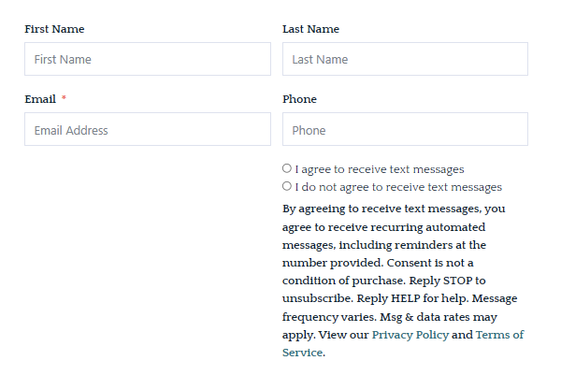

Please fill out form and email to info@myvipwindows.com